Experiment 17: Edge Detection using Sobel Matrix along X axis
Software / Tools: Python · OpenCV (cv2)

AIM
To detect vertical edges in an image using the Sobel operator along the X direction.
ALGORITHM
1. Import OpenCV.
2. Read the image and convert it to grayscale.
3. Apply cv2.Sobel() with dx=1, dy=0 to compute the gradient along the X axis.
4. Convert the result back to an 8-bit displayable image using cv2.convertScaleAbs().
5. Display and save the Sobel-X edge image.
PROGRAM (SOURCE CODE)
import cv2

img = cv2.imread("image.jpg")
gray = cv2.cvtColor(img, cv2.COLOR_BGR2GRAY)

sobel_x = cv2.Sobel(gray, cv2.CV_64F, 1, 0, ksize=3)
sobel_x = cv2.convertScaleAbs(sobel_x)

cv2.imshow("Sobel X", sobel_x)
cv2.waitKey(0)
cv2.destroyAllWindows()

OUTPUT
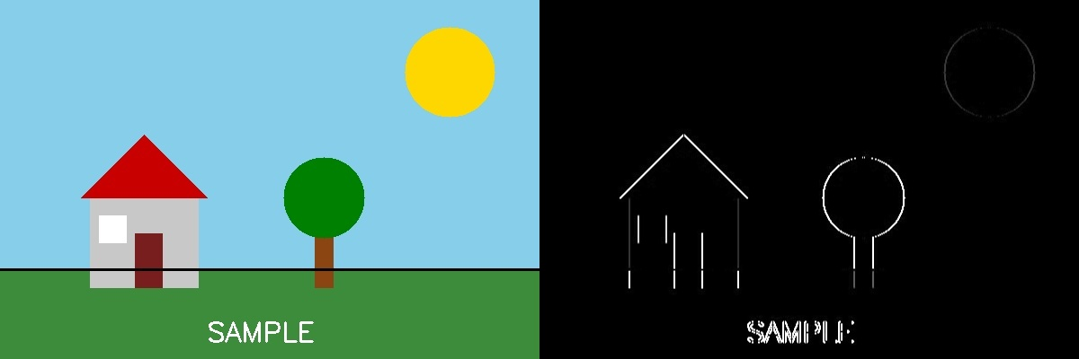
Fig. 17 — Output of Experiment 17: Edge Detection using Sobel Matrix along X axis.
RESULT
Detect vertical edges in an image using the Sobel operator along the X direction — completed successfully, as demonstrated in the output shown above.

